You will need:

SQL Server or SQL Server Express

Microsoft SQL Server Management Studio

Internet Information Services (IIS) Manager

Software Package

**Download SQL**

To download SQL Server or SQL Server Express, go to <https://www.microsoft.com/en-us/sql-server/sql-server-downloads>

**Download Microsoft SQL Server Management Studio**

To download Microsoft SQL Server Management Studio, go to <https://docs.microsoft.com/en-us/sql/ssms/download-sql-server-management-studio-ssms?view=sql-server-ver15>

**Download Internet Information Services (IIS) Manager**

To download IIS, you will need Microsoft's Web Platform Installer. It can be found here <https://www.iis.net/downloads/microsoft/web-platform-installer>

Once downloaded, run the Web Platform installer. Select add next to IIS-WebServer, IIS: Net Extensibility 4.5, and IIS: ASP.Net 4.5.

You will also need the .Net Core Hosting Bundle. This link will download the installer:

<https://download.visualstudio.microsoft.com/download/pr/c887d56b-4667-4e1d-9b6c-95a32dd65622/97e3eef489af8a6950744c4f9bde73c0/dotnet-hosting-5.0.8-win.exe>

After Installing the .Net Core Hosting Bundle, restart IIS. You can do this by going to Services app and right clicking on World Wide Web Publishing Service and selecting restart

**Download Ticket Package**

You will have to download the package found on <https://github.com/Prannet/TicketSystem>

Click the green button that says code and select download zip.

**Setting up the Ticket System**

Once you have everything needed you can now set up your ticket system. Begin by opening Internet Information Services (IIS) Manager, Microsoft SQL Server Manager, and the file explorer. In the file explorer, extract the TicketSystem file where it was downloaded. In this folder there is a TicketSystem folder and a databaseTable file (remember this file for later). **Copy the SystemTicket file folder**. Navigate to the wwwroot folder found in C:\inetpub\wwwroot. Paste the system into wwwroot. While you are here, open the TicketSystem folder and open appsettings.JSON in a text editor such as notepad.

**Connection String and Database**

Swap over to Microsoft SQL Server Management Studio. For this step you will need the name of your SQL Server instance. This can be found as the name of your root node in Microsoft SQL Server Management Studio.

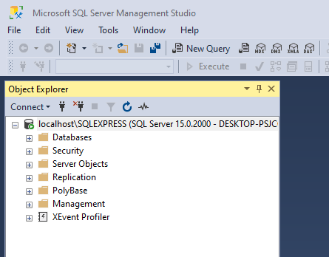

You will need to create a database. Right click Databases and select New Database…

The database name is TicketDb. Press okay.

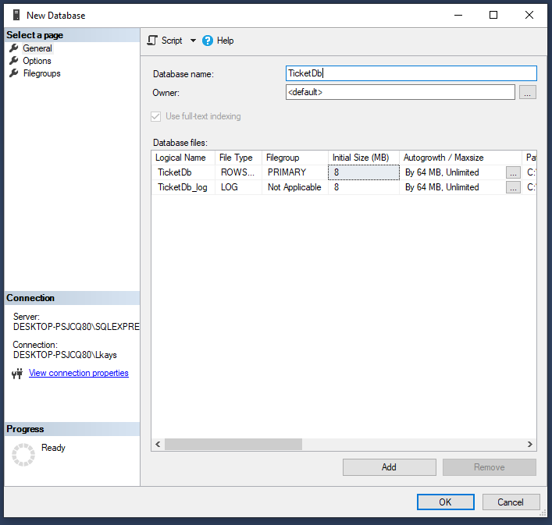

Expand the database folder. Right click the new TicketDb and select New Query. Here you will create all the tables needed for your database. Copy all of the text from databaseTables.txt found in the extracted zip folder and paste it into the query. Press execute.

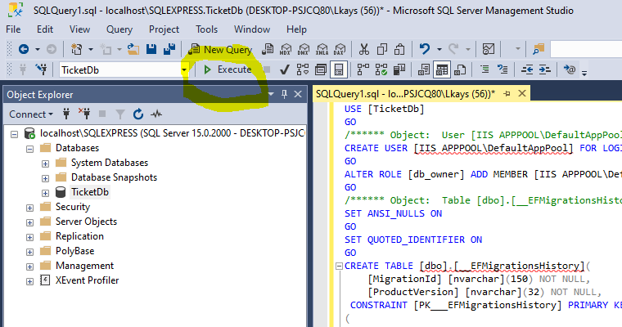

Switch over to the file appsettings.json. replace [*SQLServerInstance*] with the name of your SQL server (found at the top node of Microsoft SQL Server Management Studio) :

"DefaultConnection": "Server=[*SQLServerInstance*];Database=TicketDb;Trusted_Connection=True;MultipleActiveResultSets=true"

**Be sure to remove the [ ]’s and add a second \** Save and close the file.

For example :

"DefaultConnection": "Server=localhost\\SQLEXPRESS;Database=TicketDb;Trusted_Connection=True;MultipleActiveResultSets=true"

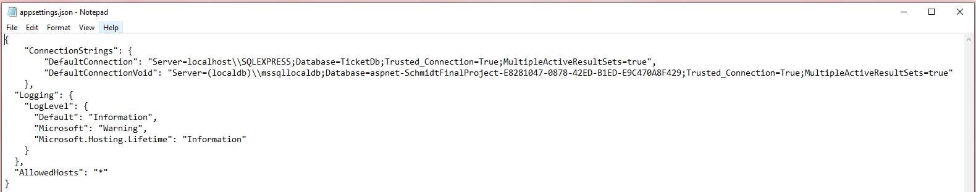

When you attempt to save this file, you may not have permission to do so. If that is the case, right click the appsettings file and select properties. Select the Security tab. Mid way down there will be a “To change permissions, click edit” prompt. Click edit. Click add. Click advanced. Click find now. In the scroll menu, select *everyone*. Press okay twice. When you are on the *Permissions for Downloads* window, make sure everyone is highlighted and in the scroll menu make sure Full control is selected.

**Running the Ticket System**

Now we will run the Ticket System. Switch over to IIS. In the connections panel, navigate into Desktop > Sites > Default Website. Right click the Default Web Site and select refresh. Here you will see the Ticket System. Right click the ticket system and select Convert to Application. Press okay. Now you can browse the site by right clicking Ticket System > Manage Application > Browse. Or you can simply open up a browser and type in http://localhost/TicketSysytem

